WESTRAFO GHANA LTD
PRESENTS
THREE PHASE TRANSFORMERS SEMINAR:
TECHNOLOGY, USE AND MAINTENANCE
Presented by Westrafo CEO Alberto Cracco
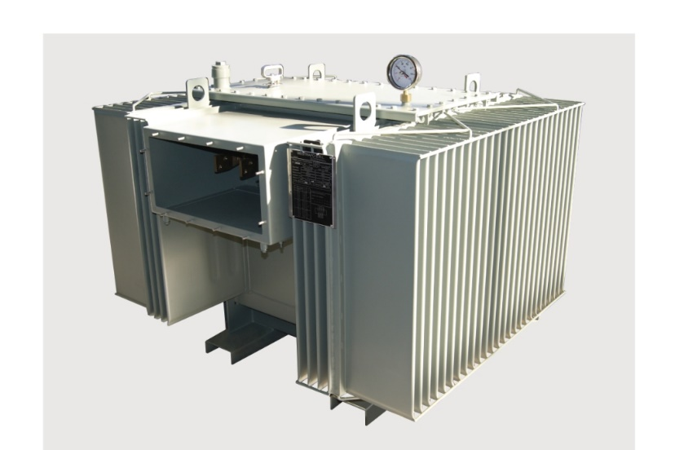
(2)Name:
Company:
Email:
Tel:

(1)Name:
Company:
Email:
Tel:

Yes, I wish to register to the above seminar, details as follows:
AGENDA:
10.00-10.15 Registration Seminar & Coffee Welcome
10.15-10.30 Westrafo Group presentation
10.30-11.00 Westrafo Ghana LTD: Project overview
11.00-12.00 Westrafo Technology presentation
12.00-13.00 Use and Maintenance of transformers
13.00-13.30 Q&A & Closing

Contact: Mr David Darkwa
Ph. +2333200734576
P.O. Box 851, Tema COMM1. Accra Ghana
Email: david.darkwa@westrafo.com
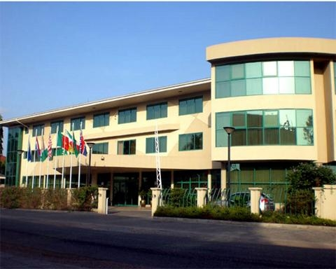
Alisa Hotel North Ridge Hotel

Time 10 – 13.30
21 Dr. Isert Road - North Ridge,
P. O. Box 1111, Accra - Ghana

